**NAME : SURAJ SAHANI**

**PROJECT : SNAKE GAME – JAVA GUI APPLICATION**

**FIRST :-**

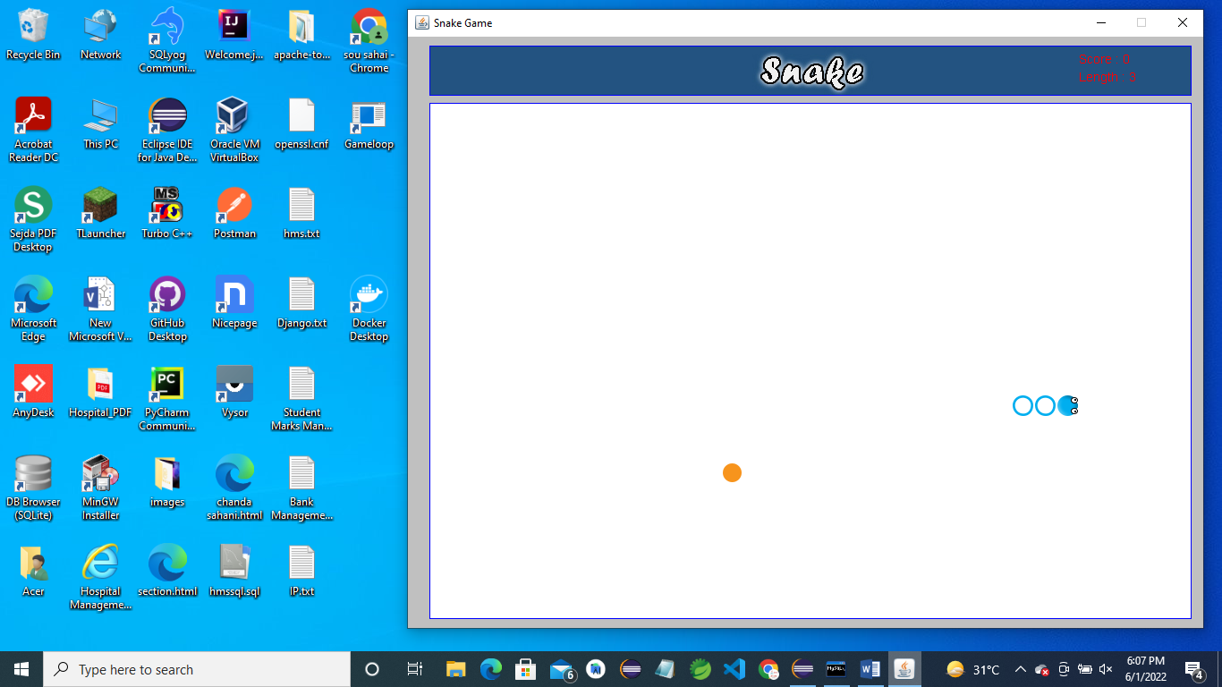

**SECOND :-**

